1. Create a folder called learn_git.



2. Create a file called third.txt.

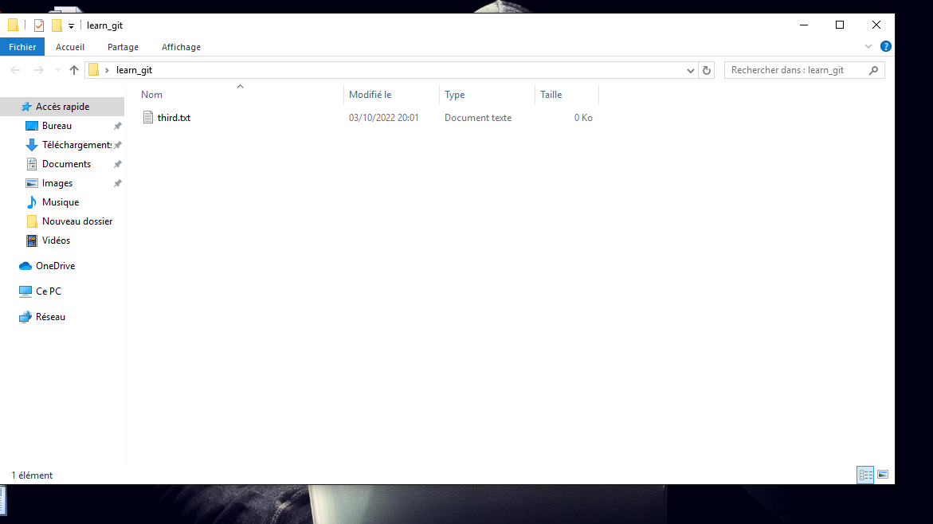

3. nitialize an empty git repository./ Add third.txt to the staging area./ Commit with the message "adding third.txt".

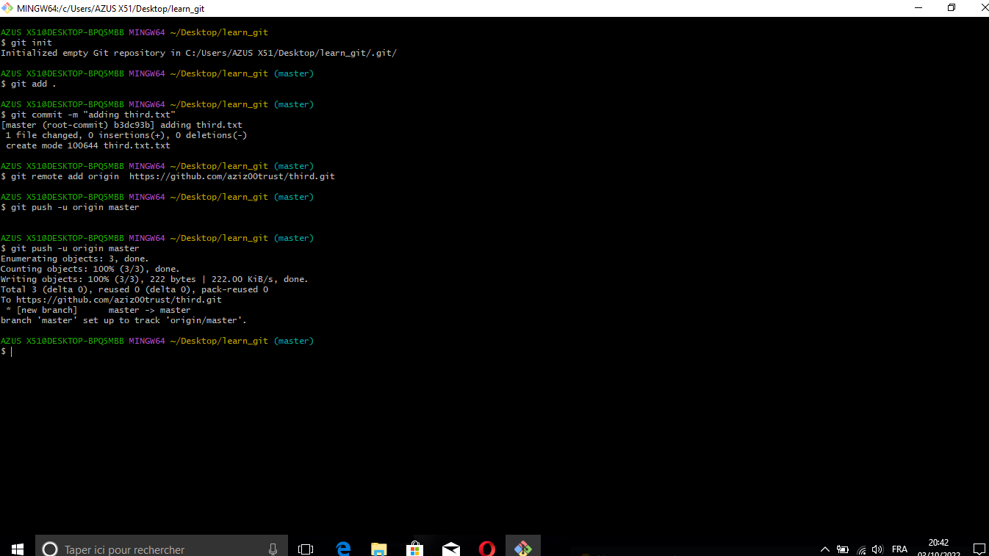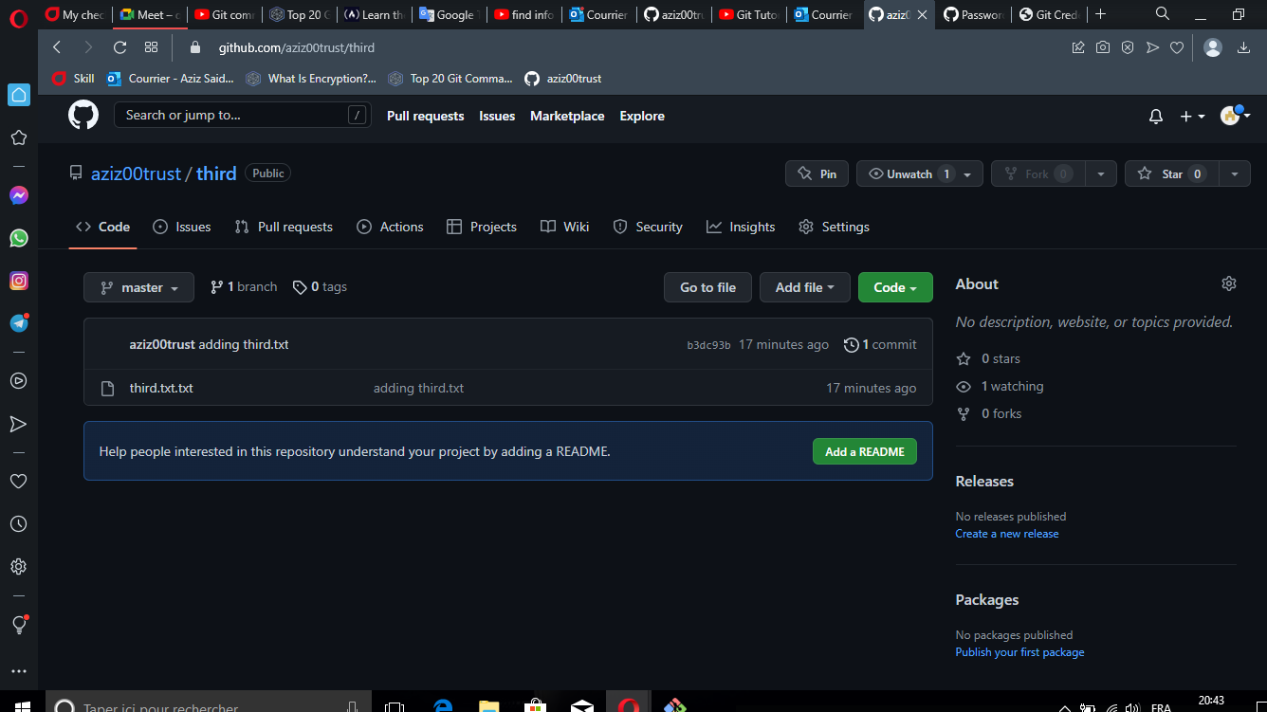

4. Check out your commit with git log.

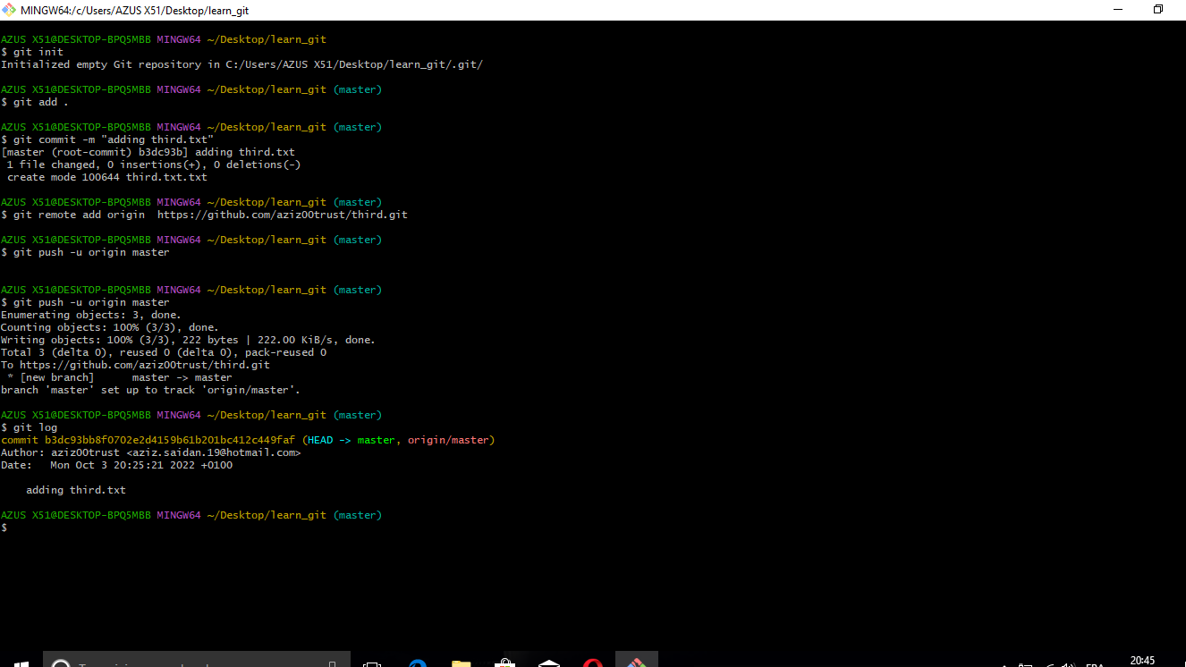

5. Create another file called fourth.txt/Add fourth.txt to the staging area/Commit with the message "adding fourth.txt"

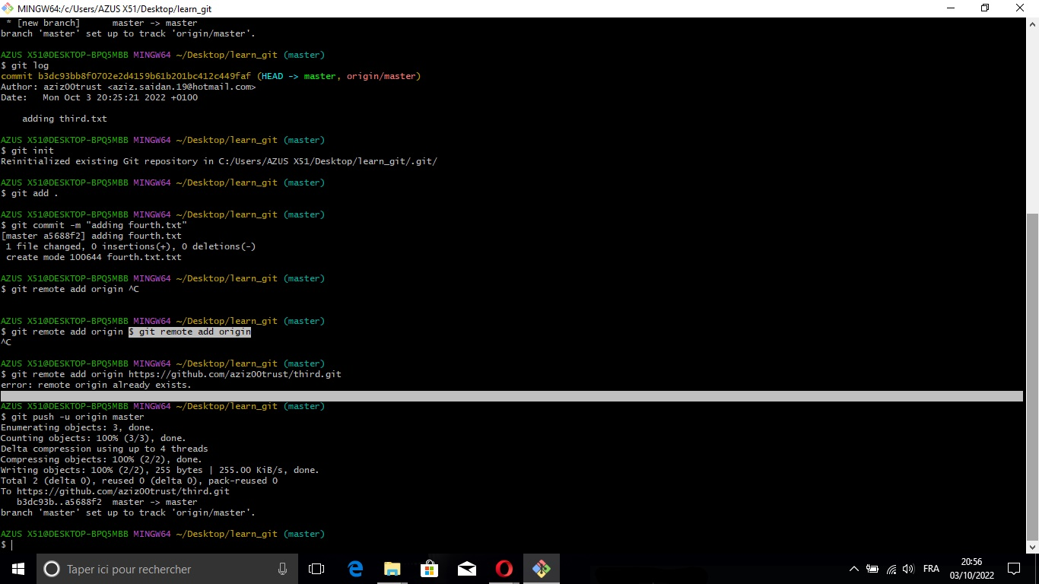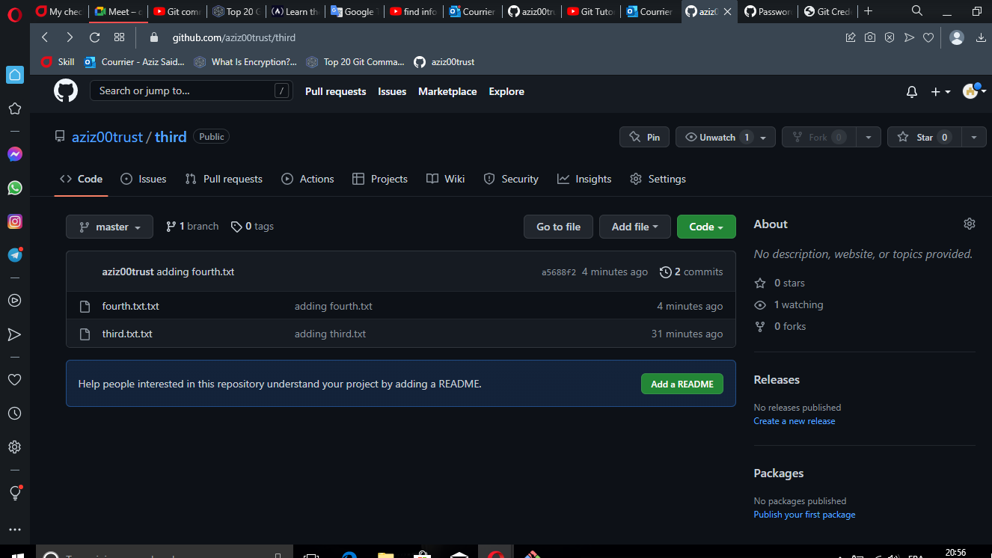

6. Remove the third.txt file.

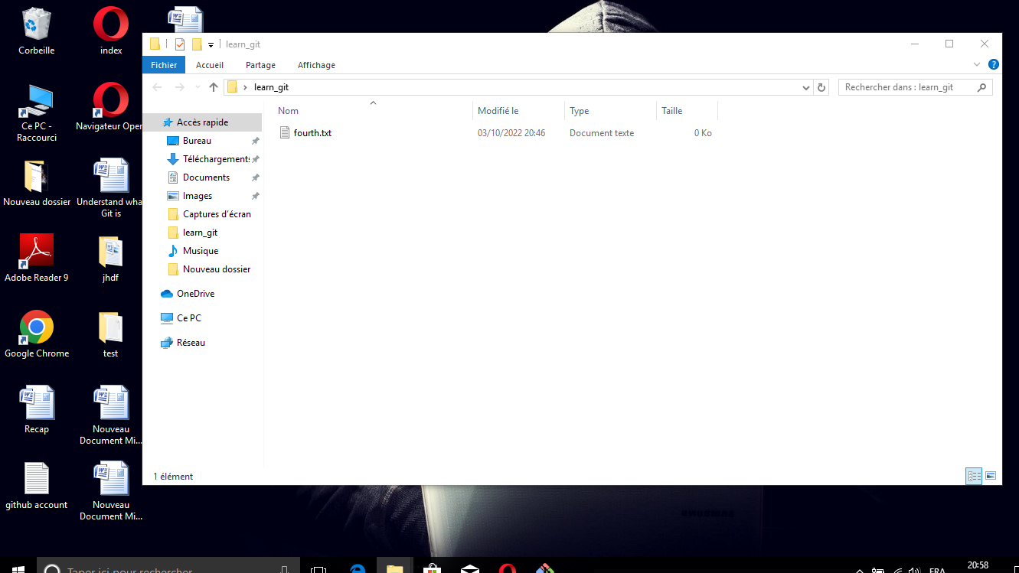

1. 7. Add this change to the staging area. (Using the command "git add . "/Commit with the message "removing third.txt".

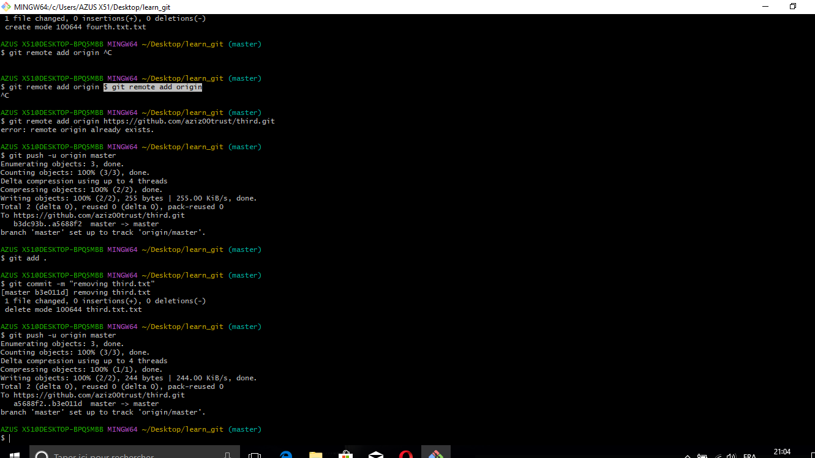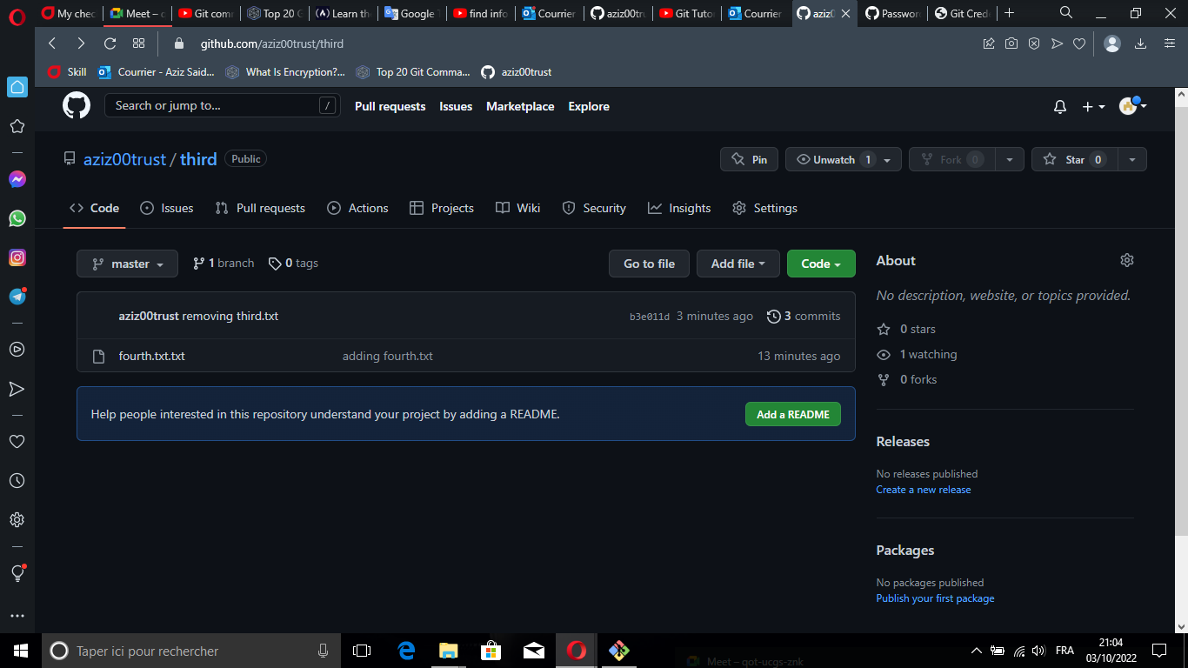

8. Check out your commits using git log.

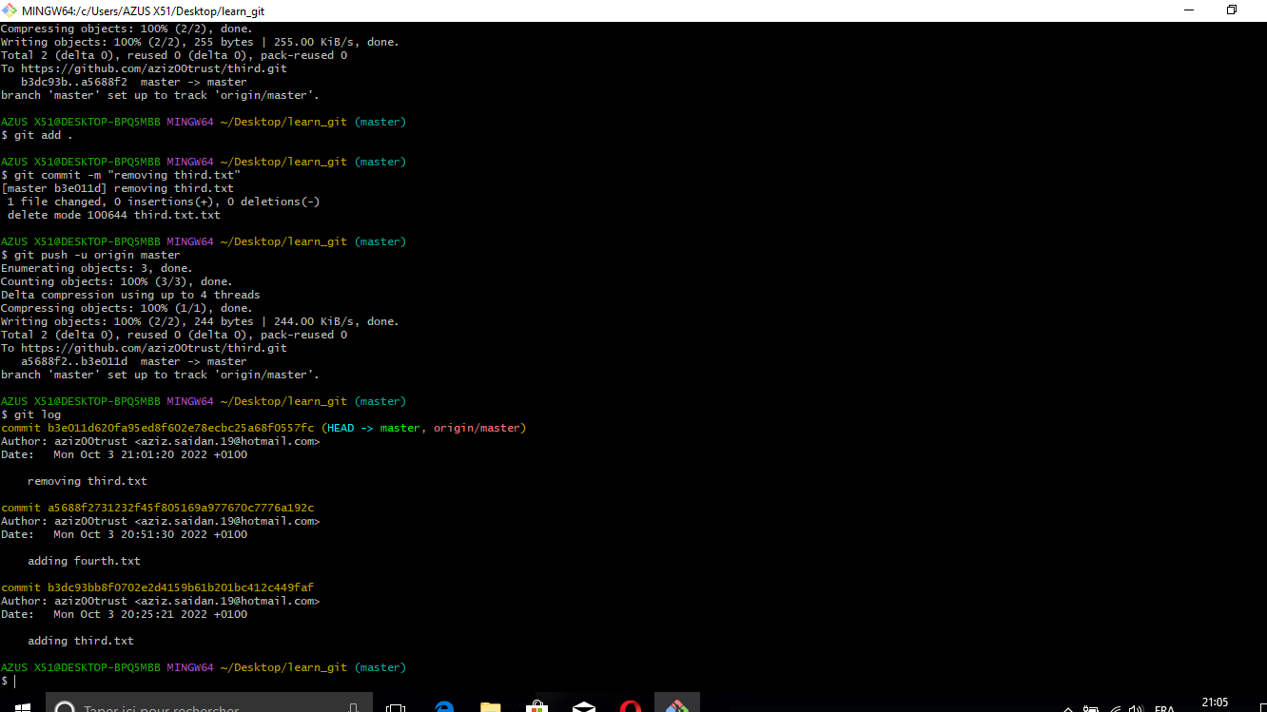

9. Change your global settings to core.pager=cat

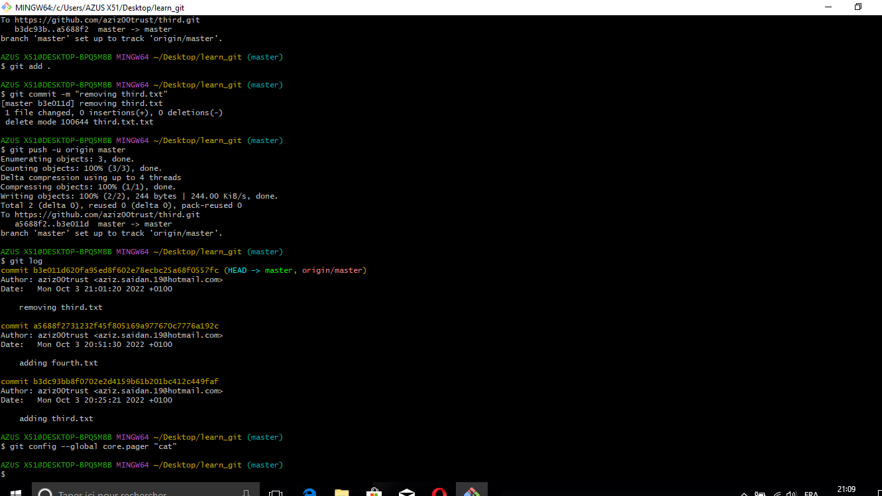

10. Write the appropriate command to list all the global configurations for git on your machine.

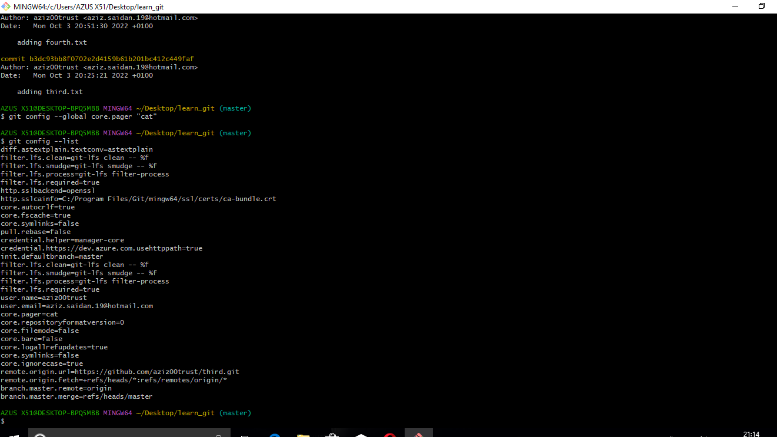

11. You can type git config --global to find out how to do this.

